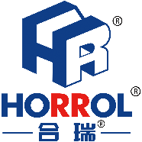

始于心，终于心 www.horrol.com
专业电子生产设备制造商 / Professional electronic production equipment manufacturer

全自动多功能微型上板机
Full automatic multi-function micro board loader
此设备应用于SMT生产线电路板的送板操作
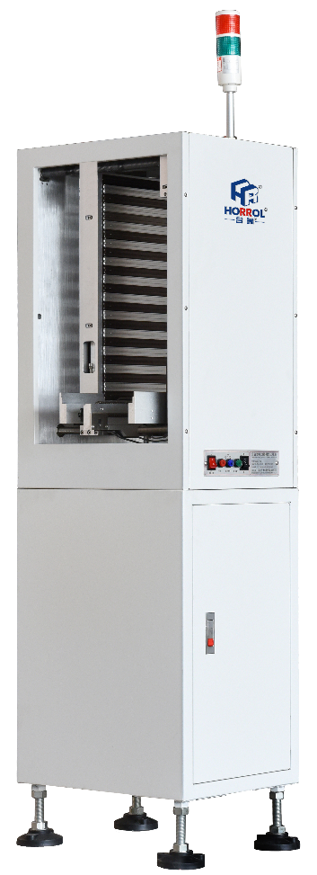
This equipment is used for board feeding operation of SMT production line circuit board
1、仅占地0.2M平方，机身面积小，不用框后更加减少占地面积，操作灵活简单
2、实用性强：半自动，全自动印刷机、贴片机均可使用，单双面板都可放置，无板自动报警
3、可靠性强：运动量小，磨损小，全部为金属材料，拥有防卡板感应保护装置
4、24v短路信号，无需接气电动推板更稳定高效
5、机械按键操作，机械感应、伞子齿轮自动调平PCB板
6、可根据客户尺寸要求定制

Features of micro board computer:
1. It only covers an area of 0.2m square, and the fuselage area is small. It can reduce the floor area without frame, and the operation is flexible and simple
2. Strong practicability: semi-automatic, full-automatic printing machine, Mounter can be used, single and double-sided board can be placed, no board automatic alarm
3. Strong reliability: small amount of movement, small wear, all metal materials, with anti card inductive protection device
4. 24 V short circuit signal, no need to connect gas, electric push plate is more stable and efficient
5. Mechanical key operation, mechanical induction, bevel gear automatic leveling PCB board
6. Can be customized according to customer size requirements
微型上板机技术规格参数 / Technical specifications and parameters of micro board loader

设备型号Equipment model | HR-OK-6000 | HR-OK-8000
外形尺寸Equipment size | 510x470x1470mm | 550x500x1470mm
允许零件高度Allowable part height | 0.1~10mm | 0.1~10mm
轨道高度Track height | 900±20mm | 900±20mm
电压功率Voltage power | 220v/50w | 220v/50w
传输速度Transmission speed | 200mm/s | 200mm/s
下降速度Descent speed | 25mm/s | 25mm/s
工作环境温度Working environment temperature | 0~50℃ | 0~50℃
占地面积Area covered | 0.2m² | 0.3m²
允许板宽度Allowable board width | （50-450）x（55-280）mm | （50-450）x（55-350）mm
传送方向Transmission direction | 左 ⇋ 右left ⇋ right | 左 ⇋ 右left ⇋ right
储板数量Number of storage boards | 50pcs | 50pcs
设备重量Equipment weight | 90kg | 110kg
上述产品由广东海森堡科技有限公司及广东合瑞科技有限公司设计、生产

