始于心，终于心 www.horrol.com
专业电子生产设备制造商 / Professional electronic production equipment manufacturer

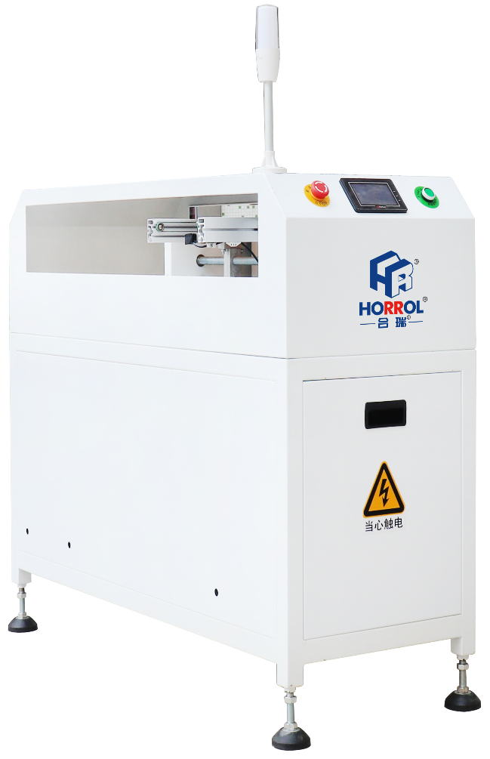
平行移栽机
Parallel loader
此设备用于SMT和生产线合并为一或一条线分流成两条线，本机用于两级之间的错位平移，将PCB或者是PCBA板平移至下一设备继续生产，用于合线或者平移平台。

This equipment is used for SMT and production line merging into one line or splitting into two lines. This machine is used for dislocation translation between two levels, moving PCB or PCBA board to the next equipment to continue production, and for assembly or translation platform.

1、结实和稳定的设计
2、PLC控制系统
3、控制面板为LED真彩触摸屏
4、光电感应器控制起始
5、配备标准信号，可与其他设备进行在线接驳

1. Strong and stable design
2. PLC control system
3. The control panel is led true color touch screen
4. Photoelectric sensor control start
5. Equipped with standard signal, it can connect with other equipment online

平行移载机技术规格参数 / Technical specifications of Parallel loader

设备型号Equipment model | HR-PTA-686 | HR-PTA-3000 | HR-PTA-3500 | HR-PTA-4500
控制模块Control module | PLC工控 | PLC工控 | PLC工控 | PLC工控
外形尺寸Boundary dimension | 1300x600x1050mm | 3000x600x1050mm | 3500x600x1050mm | 4500x600x1050mm
电源及负荷Power supply and load | 220v/0.3kw | 220v/0.3kw | 220v/0.3kw | 220v/0.3kw
小车配置Trolley configuration | 单车/双车single cart/double cart | 单车/双车 | 单车/双车 | 单车/双车
传送高度Transfer height | 900±20毫米900 ± 20 mm | 900±20毫米 | 900±20毫米 | 900±20毫米
电路板厚度Board thickness | ≥0.4毫米≥ 0.4mm | ≥0.4毫米 | ≥0.4毫米 | ≥0.4毫米≥ 0.4mm
小车配置Trolley configuration | 290/350/450mm | 290/350/450mm | 290/350/450mm | 290/350/450mm
感应器Sensor | 光电感应 | 光电感应 | 光电感应 | 光电感应
移动速度Movement speed | 2000mm/s | 2000mm/s | 2000mm/s | 2000mm/s
故障检测Fault detection | I/O信号检测I / O signal detection | I/O信号检测 | I/O信号检测 | I/O信号检测
品牌Brand | 合瑞/HORROL | 合瑞/HORROL | 合瑞/HORROL | 合瑞/HORROL

上述产品由广东海森堡科技有限公司及广东合瑞科技有限公司设计、生产

