始于心，终于心 www.horrol.com
专业电子生产设备制造商 / Professional electronic production equipment manufacturer

高效缓存机
High efficiency buffer machine
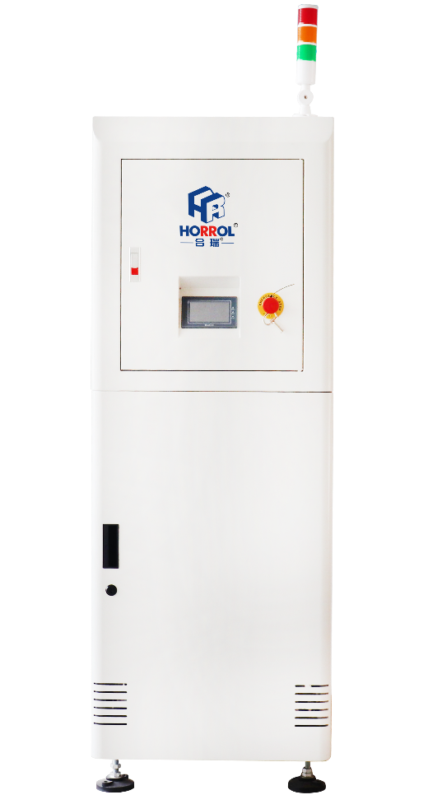
此设备应用于SMT生产线电路板的缓冲操作
This equipment is applied to buffer operation of circuit board in SMT production line
1、置于主设备后，当线体速度不协调时起缓冲作用
2、置于炉子后面起缓冲和冷却作用，避免PCB板卡在炉子里
3、20层铝制存板凹槽，3.5mm扁平皮带传送
4、松下PLC 带各种选配功能
5、先进先出，后进先出，NG/OK，直通四个功能可选
6、可选择的步距：20、40、60mm
7、全封闭结构安全性更高
8、TFT 触摸屏，操作简单；兼容SMEMA。
1. After the main equipment, when the line body speed is not coordinated, it plays a buffer role
2. It is placed behind the furnace for buffering and cooling to avoid PCB stuck in the furnace
3. 20 layer aluminum storage plate groove, 3.5mm flat belt transmission
4. Panasonic PLC with various optional functions
5. First in first out, last in first out, ng / OK and direct connection are optional
6. Optional step length: 20、40、60mm
7. The safety of fully enclosed structure is higher
8. TFT touch screen, easy to operate；Compatible with SMEMA。
高效缓冲机技术规格参数 / Technical specifications of High efficiency Buffer machine

设备型号Equipment model | HR-BM-460
外形尺寸Overall Dimension | 600x1200x1700mm
控制元件Control System | PLC、触摸屏
PCB板尺寸PCB Size | L（50x5）xW（500x460）
PCB板传输方向PCB Conveyor Direction | 左⇌右left ⇌ right
传输高度Conveyor Height | 920±30(mm)
步踞选择Pitch Selection | 20、40、60mm
循环时间Cycle time | 约15秒About 15 seconds
电源Power | AC220V,50/60HZ
功率Power Consumption | 0.7kw
气压Air pressure | 0.4~0.6Mpa
最大容量Maximum capacity | 20pcs
重量Weight | 200kg

上述产品由广东海森堡科技有限公司及广东合瑞科技有限公司设计、生产

