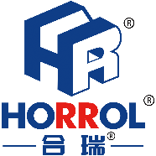

始于心，终于心 www.horrol.com
专业电子生产设备制造商 / Professional electronic production equipment manufacturer

层叠式送板机
Stacking machine
此设备应用于SMT生产线电路板的送板操作
This equipment is used for board feeding operation of SMT production line circuit board

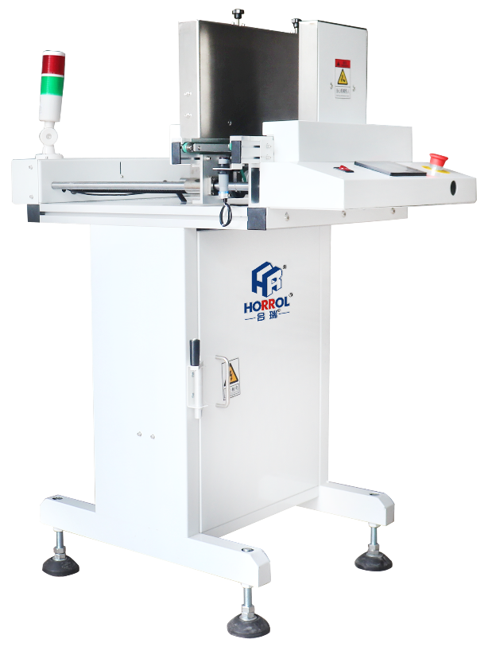
层叠式送板机特性：
- 结实和稳定的机械设计
- PLC真彩屏控制系统，送板速度快
- 叠板和直通接驳一体
- 配备标准信号，可与其他设备进行在线接驳
- 可最大运行460mm宽pcb板

Characteristics of cascade plate feeder:
1. Strong and stable mechanical design
2. PLC true color screen control system, fast plate feeding speed
3. Lamination and straight connection are integrated
4. Equipped with standard signal, it can connect with other equipment online
5. It can run 460mm wide PCB board

叠送板模式和接驳直通过半模式可在显示屏上自由切换
Stacking plate mode and connecting straight through mode can be freely switched on the display screen

层叠式叠板机技术规格参数 / Technical specifications and parameters of Stacking machine

设备型号Equipment model | HR-SM-460
外形尺寸Boundary dimension | 600x650x1200mm
控制模块Control module | 西门子PLC工控
电源及负荷Power supply and load | AC220V，≤0.3kw
传送高度Transfer height | 920±20毫米920 ± 20 mm
传送方向Direction of transmission | 左-右/右-左（选配）Left to right or right to left
电路板厚度Board thickness | ≥0.4毫米≥ 0.4mm
感应器Sensor | 光电感应Photoelectric induction
传送动力Transmission power | 步进及运输电机Lifting and transportation motor
功能function | 层叠送板+直通接驳Stacked feeding board+direct connection
故障检测Fault detection | I/O信号检测I / O signal detection
PCB尺寸（长x宽）PCB size (LxW) | （50~50）x（500x460）mm
设备重量Equipment weight | 200kg
更多信息，可进入官方网站了解 | www.horrol.com/www.hisenberge.com

上述产品由广东海森堡科技有限公司及广东合瑞科技有限公司设计、生产

