始于心，终于心 www.horrol.com
专业电子生产设备制造商 / Professional electronic production equipment manufacturer

半自动锡膏印刷机
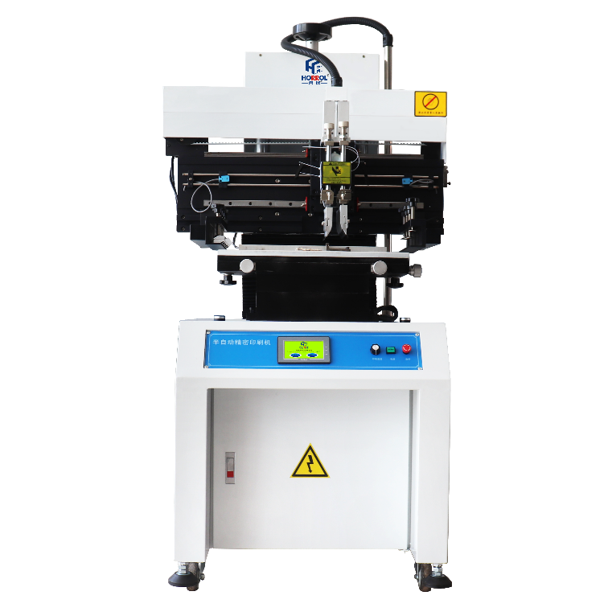
Semi automatic solder paste printing machine
此设备应用于SMT生产线电路板的刮锡膏操作
This equipment is used for scraping solder paste in SMT production line
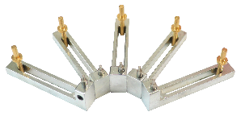
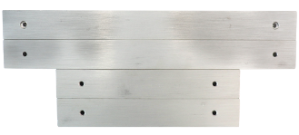
半自动锡膏印刷机特点：
1、蜂窝平台定位
2、双片悬浮刮刀
3、三位一体电磁阀控制
4、X、Y轴旋钮微调
5、PLC集成控制
6、真彩屏简易操作页面
Features of Semi automatic solder paste printing machine:
1. Positioning of cellular platform
2. Double suspension scraper
3. Three in one solenoid valve control
4. Fine adjustment of x-axis and y-axis knobs
5. PLC integrated control
6. Simple operation page of true color screen
半自动锡膏印刷机技术规格参数 / Technical specification parameters of semi-automatic solder paste printing machine

设备型号Equipment model | HR-SAPP-400 | HR-SAPP-600 | HR-SAPP-1200 | HR-SAPP-1500
外形尺寸Boundary dimension | 700x900x1680mm | 900x900x1680mm | 1500x900x1680mm | 1800x900x1680mm
工作台板Worktable board | 500x320mm | 700x320mm | 1300x320mm | 1600x320mm
钢网允许尺寸Steel mesh size | 600x450mm | 800x450mm | 1400x450mm | 1700x450mm
控制模块Control module | PLC 工控 | PLC工控 | PLC工控 | PLC工控
触摸彩屏Touch color screen | 4.3寸/inch Kineal | 4.3寸/inch Kineal | 4.3寸/inch Kineal | 4.3寸/inch Kineal
主动气缸Main cylinder | SC63x150-S | SC63x150-S | SC63x150-S | SC63x150-S
刀头气缸Cutter head cylinder | CDU25x50 | CDU25x50 | CDU25x50 | CDU25x50
滑动导轨Slide guide | 直线导轨linear guide rail | 直线导轨linear guide rail | 直线导轨linear guide rail | 直线导轨linear guide rail
变频器Frequency converter | ENC | ENC | ENC | ENC
印刷精度Printing accuracy | ±0.02mm | ±0.02mm | ±0.02mm | ±0.02mm
微调范围Fine tuning range | ±10mm | ±10mm | ±10mm | ±10mm
移动电机Mobile motor | 三相/60w Three phase / 60W | 三相/60w Three phase / 60W | 三相/60w Three phase / 60W | 三相/60w Three phase / 60W
电源电压Supply voltage | 单相/220v Single phase / 220 V | 单相220v Single phase / 220 V | 单相220v Single phase / 220 V | 单相220v Single phase / 220 V
启动功率Starting power | 0.2kw | 0.2kw | 0.2kw | 0.2kw
气源Air source | 0.5Mpa-0.8Mpa | 0.5Mpa-0.8Mpa | 0.5Mpa-0.8Mpa | 0.5Mpa-0.8Mpa
移动方向Direction of movement | 左右可移Left and right movable | 左右可移Left and right movable | 左右可移Left and right movable | 左右可移Left and right movable
移动速度Movement speed | 0~2200mm/min | 0~2200mm/min | 0~2200mm/min | 0~2200mm/min
设备重量Equipment weight | 195kg | 245kg | 280kg | 340kg

上述产品由广东海森堡科技有限公司及广东合瑞科技有限公司设计、生产

