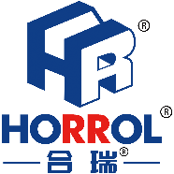

始于心，终于心 www.horrol.com
专业电子生产设备制造商 / Professional electronic production equipment manufacturer

NG/OK收板机
NG/OK Loader
此设备应用于SMT生产线电路板的好坏板收板操作
This equipment is applied to the board closing operation of circuit board in SMT production line
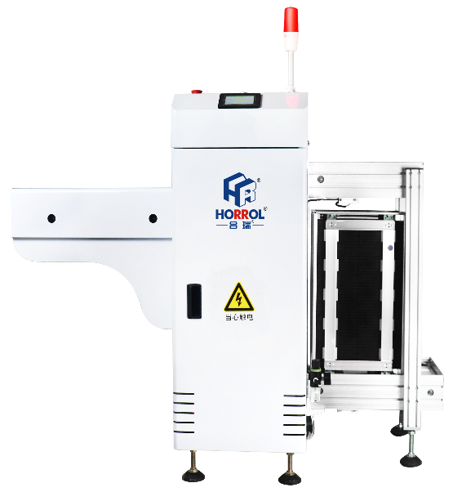
1、PLC集成控制系统
2、控制面板为LED真彩触摸屏
3、步距可分为四种：10、20、30、40mm
4、可放置两个料架，实现自动换框操作
5、具有防卡板特殊感应系统，拥有I/O信息故障检测
6、方向可选择从左往右或从右往左
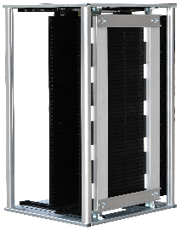
1. PLC integrated control system
2. The control panel is led real color touch screen
3. There are four steps: 10, 20, 30 and 40mm
4. Two material racks can be placed to realize
automatic frame changing operation
5. With special sensing system of anti card board and I / O
information fault detection
6. Direction can be selected from left to right or right to left
全自动下板机技术规格参数 / Technical specifications of automatic loader

设备型号Equipment model | HR-NGOK-250D
控制模块Control module | PLC工控
外形尺寸Boundary dimension | 1500x1500x1300mm
上框时间Top frame time | 约6秒About 6 seconds
料箱更换时间Change time of material box | 约20秒About 20 seconds
电源及负荷Power supply and load | 220v/0.3kw
气压及流量Air pressure and flow | 4-6bar，≤10升/分钟up to 10 L / min
传送高度Transfer height | 900±20毫米900 ± 20 mm
传送方向Direction of transmission | 左-右/右-左Left to right or right to left
电路板厚度Board thickness | ≥0.4毫米≥ 0.4mm
步距选择Step selection | 1~4（10毫米步距）1-4 (10 mm steps)
感应器品牌Sensor | 光电感应Photoelectric induction
料框尺寸Frame size | 355x320x563mm
故障检测Fault detection | I/O信号检测I / O signal detection
设备重量Equipment weight | 150kg
PCB尺寸（长x宽）PCB size (LxW) | （50~50）x（350x250）mm
配备料箱数量Number of bins equipped | 1pcs

上述产品由广东海森堡科技有限公司及广东合瑞科技有限公司设计、生产

