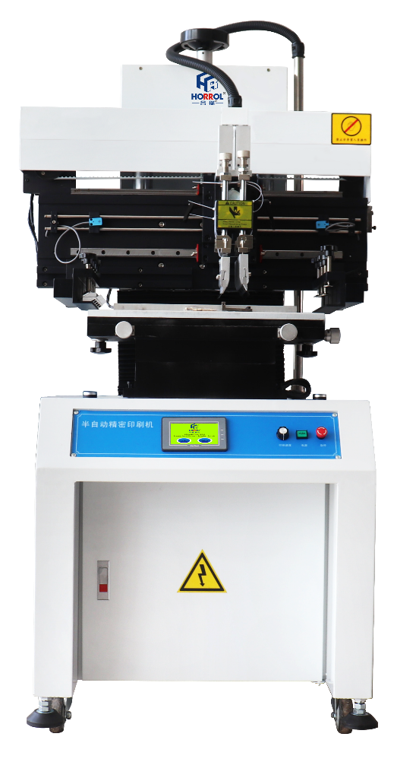

半自动精密印刷机
Semi automatic precision printing machine

产品说明书
Product description

（2021版次Edition）
前言Preface
欢迎使用本公司生产的半自动锡膏印刷机，请使用本机的操作员必须熟悉本设备机械结构电气电路界面功等才能操作本机器。因此，无论如何，请充分理解操作手册，使机器在最佳状况下运转，得到最佳的效益，同时，也希望您重视机器的安全使用。
Welcome to the semi-automatic solder paste printing machine produced by our company. The operator using this machine must be familiar with the mechanical structure, electrical circuit, interface function, etc. of this equipment before operating this machine. Therefore, in any case, please fully understand the operation manual to make the machine run under the best conditions and get the best benefits. At the same time, I hope you pay attention to the safe use of the machine.
当您手中拿到此说明书，您已经成为我们的用户或服务对象，我们将有义务有责任为您提供有关机器使用上的技术帮助，关于本书若有不明之处时，请您向公司服务部询问。
When you get this manual, you have become our user or service object. We are obliged and responsible to provide you with technical assistance on the use of the machine. If there is any ambiguity about this book, please ask the service department of the company.
使用注意事项
1、请先确定您所购买的机器的具体型号；
2、机器运转时，请对操作手册中的（安全规则与事故防止）仔细阅读；
3、操作机器时，请严格遵守（安全规则与事故防止）；
4、因设计变更或特殊的原因，交货机器的具体规格与本操作手册所编写的有时会有若干的差异，请谅解；
5用户单位如擅自在机器上改装零部件，由此引起的质量问题或机械事故，我公司不负责任；
Precautions for use
1. Please first determine the specific model of the machine you purchased;
2. When the machine is running, please read the (safety rules and accident prevention) in the operation manual carefully;
3. Please strictly observe (safety rules and accident prevention) when operating the machine;
4. Due to design changes or special reasons, the specific specifications of the delivered machine may sometimes differ from those written in this operation manual. Please understand;
5 if the user unit refits parts on the machine without authorization, our company will not be responsible for the quality problems or mechanical accidents caused thereby;
注：本操作手册的著作版权属于东莞市合瑞电子科技有限公司所有，若无公司书面许可，禁止复制或复印操作手册，同时禁止第三者使用本操作手册。
本公司保留随时修改本操作手册中所编写技术资料的权利。
Note: the copyright of this operation manual belongs to Dongguan Herui Electronic Technology Co., Ltd. without the written permission of the company, it is prohibited to copy or copy the operation manual, and no third party is allowed to use this operation manual.
The company reserves the right to modify the technical data prepared in this operation manual at any time.
目录
- 公司介绍（Company introduction）·······································（第1页）
- 设备规格技术参数（specifications and technical parameters）············（第2页）
- 设备特性（Equipment characteristics）··································（第3页）
- 安全指令（Safety Directive）···········································（第4页）
- 设备安装与操控（Equipment installation and control）··················（第13页）
- 触摸屏页面（Touch screen page）·······································（第18页）
- 设备主体构造平面图（Main structure plan of equipment）················（第19页）
- 设备详细结构平面图（Detailed structure plan of equipment）············（第20页）
- 操控示意图（Control diagram）·········································（第21页）
- 对钢网和印刷运行调整（Adjustment of steel mesh and printing operation（第22页）
- 试机和运转操作（Commissioning and operation）·························（第26页）
- 设备操作步骤（Equipment operation steps）·····························（第28页）
- 操作工艺设定流程（Operation process setting process）·················（第35页）
- 常见故障处理措施（Common fault handling measures）····················（第36页）
- 定期保全（Periodic preservation）·····································（第36页）
- 运输及吊装（Transportation and hoisting）·····························（第38页）
- 电气原理图附件（Electrical schematic diagram accessories）············（第39页）

公司介绍Company introduction
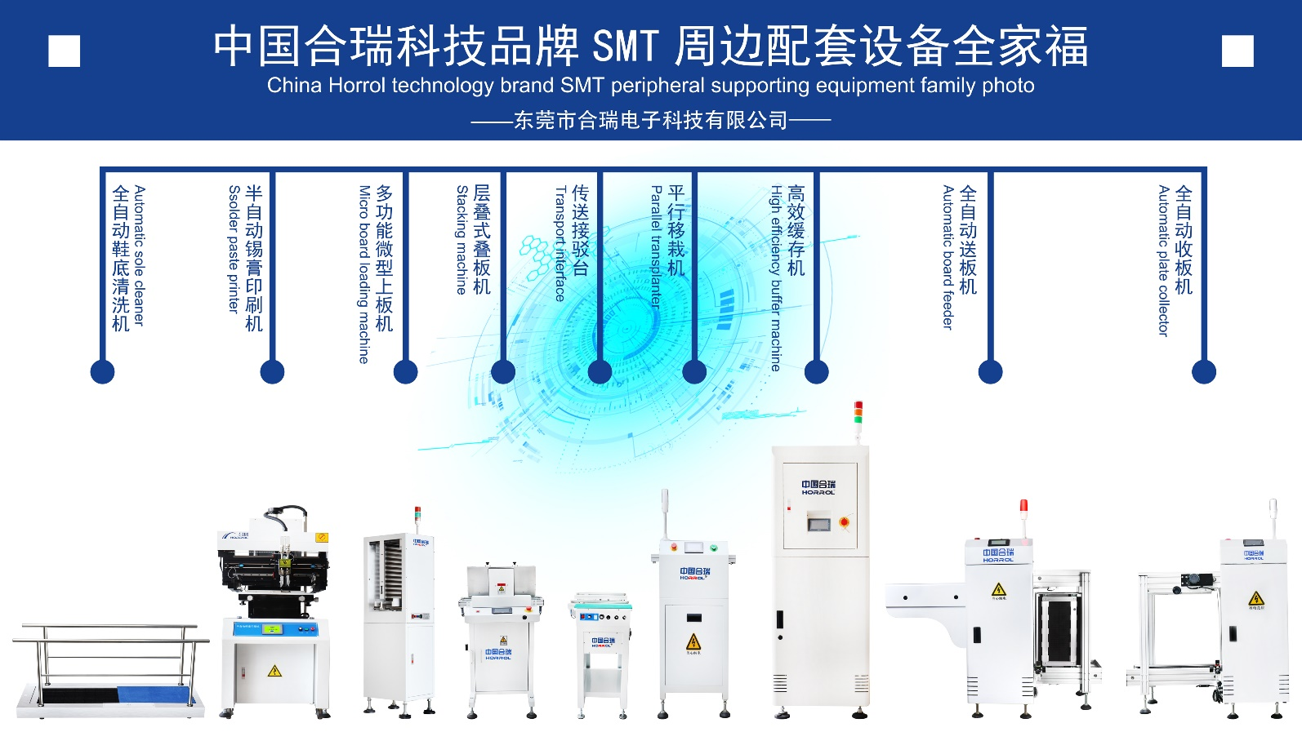

广东合瑞科技有限公司一家集研发、生产、销售、服务为一体的科技型企业，自成立以来，大胆尝试创新，汲取国内外行业经验，相继开发了鞋底清洗机、鞋底清洁机、鞋底洗鞋机、鞋底消毒机、微型上板机、全自动送板机、全自动收板机、全自动上下板机、半自动锡膏印刷机、平行移载机、全自动吸板机、层叠式叠板机、高效缓存机等智能自动化产品，坚持以科技创新为根本的宗旨，本着“亲、诚、惠、容”的企业文化核心，坚持“因您而在，为您而变；厚德载物，德行天下；创新科技，改变生活，让生活更美好”的企业文化，深耕SMT周边设备，不断探索自动化智能产品，用实际行动，坚持科学发展观，不断创新改进，秉承“一切为了客户，一切源于品质”的原则，用我们的真诚与专业提供到位的技术服务，为全球提供高标准高质量的人工智能自动化产品，为使用者创造更多价值，让生活更加美好。
Guangdong Horrol Technology Co., Ltd. is a high-tech enterprise integrating research and develop, production, sales and service. Since its establishment, it has boldly tried innovation, learned from domestic and foreign industry experience, and successively developed sole cleaner, and soles Shoe washing machine, sole disinfection machine, micro plate loading machine, automatic plate feeding machine, automatic plate receiving machine, automatic plate loading machine, semi-automatic solder paste printing machine, parallel transfer machine, automatic suction plate machine, stacked type Intelligent automation products such as stacking machines adhere to the fundamental purpose of scientific and technological innovation, in line with the core of the corporate culture of "Friendship, Sincerity, Benefit, and Tolerance", and insist on "Live because of you,change for you,great virtue bears all things, virtue spreads over the world,innovating science and technology, changing life,make life better" corporate culture, adhere to the original intention of "Start with heart, end with heart", deeply cultivate SMT peripheral equipment, continuously explore automated intelligent products, use practical actions, and adhere to the scientific development concept , Continuous innovation and improvement, adhering to the principle of "All for customers, all from quality", with our sincerity and professionalism to provide in-place shoe washing machine technical services, to provide enterprises and families with high-standard and high-quality artificial intelligence automation products. Create more value for users and make life better.
设备规格技术参数
Equipment specifications and technical parameters
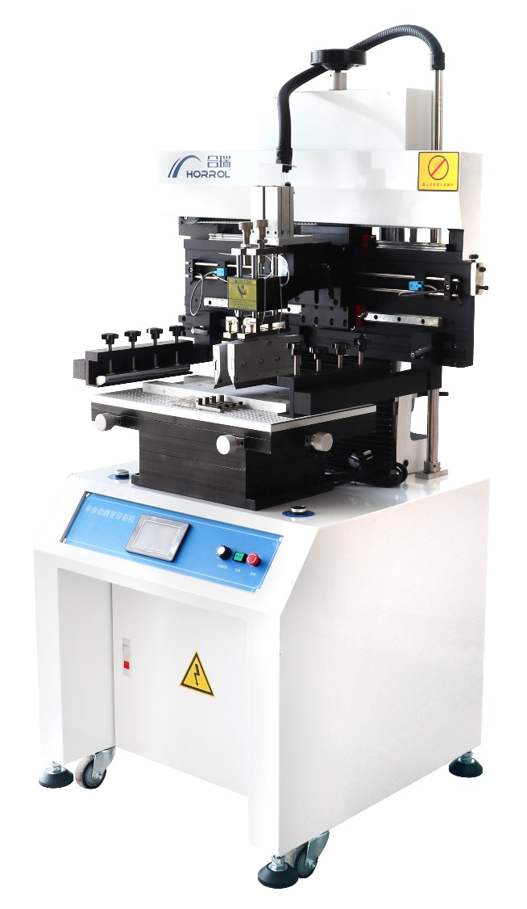
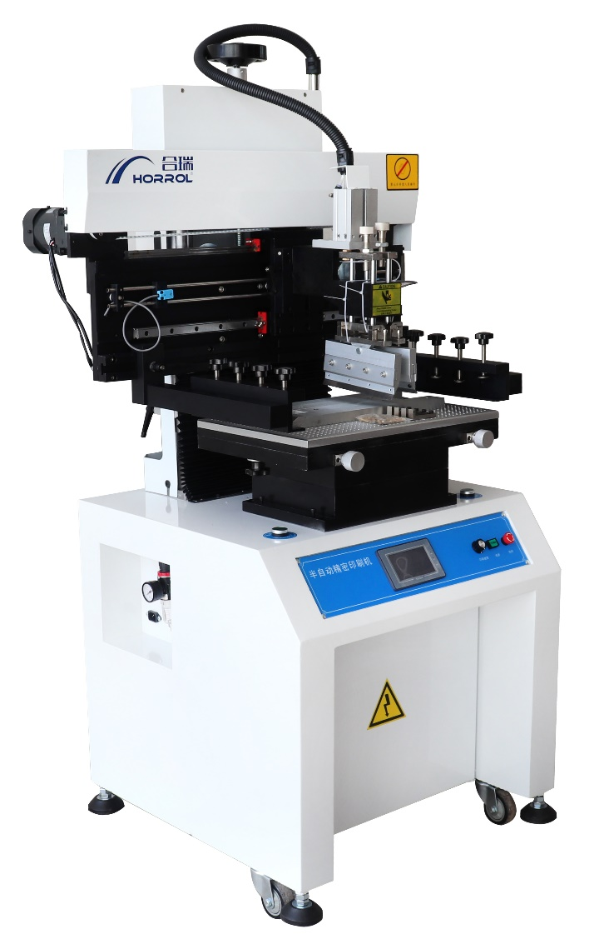
—

设备型号Equipment model | HR-SAPP-400 | HR-SAPP -600 | HR-SAPP -1200 | HR-SAPP -1500
外形尺寸Boundary dimension | 700x900x1680mm | 900x900x1680mm | 1500x900x1680mm | 1800x900x1680mm
工作台板Worktable board | 500x320mm | 700x320mm | 1300x320mm | 1600x320mm
钢网允许尺寸Steel mesh size | 600x450mm | 800x450mm | 1400x450mm | 1700x450mm
控制模块Control module | 西门子PLC | 西门子PLC | 西门子PLC | 西门子PLC
触摸彩屏Touch color screen | 4.3寸/inch Kineal | 4.3寸/inch Kineal | 4.3寸/inch Kineal | 4.3寸/inch Kineal
主动气缸Main cylinder | SC63x150-S | SC63x150-S | SC63x150-S | SC63x150-S
刀头气缸Cutter head cylinder | CDU25x50 | CDU25x50 | CDU25x50 | CDU25x50
滑动导轨Slide guide | 直线导轨linear guide rail | 直线导轨linear guide rail | 直线导轨linear guide rail | 直线导轨linear guide rail
变频器Frequency converter | ENC | ENC | ENC | ENC
印刷精度Printing accuracy | ±0.02mm | ±0.02mm | ±0.02mm | ±0.02mm
微调范围Fine tuning range | ±10mm | ±10mm | ±10mm | ±10mm
移动电机Mobile motor | 三相/60w Three phase / 60W | 三相/60w Three phase / 60W | 三相/60w Three phase / 60W | 三相/60w Three phase / 60W
电源电压Supply voltage | 单相/220v Single phase / 220 V | 单相220v Single phase / 220 V | 单相220v Single phase / 220 V | 单相220v Single phase / 220 V
启动功率Starting power | 0.2kw | 0.2kw | 0.2kw | 0.2kw
气源Air source | 0.5Mpa-0.8Mpa | 0.5Mpa-0.8Mpa | 0.5Mpa-0.8Mpa | 0.5Mpa-0.8Mpa
移动方向Direction of movement | 左右可移Left and right movable | 左右可移Left and right movable | 左右可移Left and right movable | 左右可移Left and right movable
移动速度Movement speed | 0~2200mm/min | 0~2200mm/min | 0~2200mm/min | 0~2200mm/min
设备重量Equipment weight | 195kg | 245kg | 280kg | 340kg
设备特性
Equipment characteristics
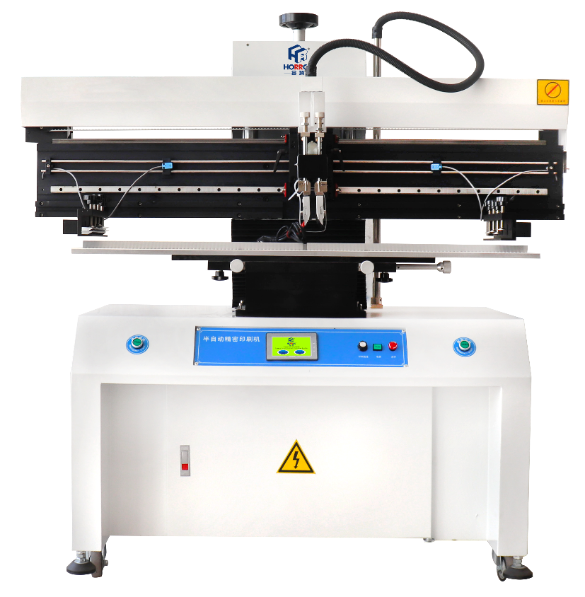
● 微电脑控制，触摸屏显示，真彩屏操作界面。
● 刮刀浮动。（类似全自动印刷机，刮刀可以自由上下浮动及自动调整与钢网水平）。
● 刮刀压力可调，（可根据不同型号刮刀的长短调节刮刀刮刀对钢网的压力）。
● 钢网离开PCB板（脱模）有分段动作，05秒可调。（即类似全自动印刷机，钢网先在2秒钟内缓慢上升脱模，然后再快速上升离开PCB板，这即避免了脱模出现的拉丝现象，节约了时间，以提高了生产效率）。
● 工作操作采用双手按键开关操作，安全可靠。
● 触摸屏菜单内可立设定刮刀左上停左下停时间，右上停右下停时间，及钢网整体上停顿下停的时间。
● PCB板的定位固定方式有基准孔定位，基准边定位及基准孔基准边同时定位，模板定位等多种不同的精确定位形式。
● 触摸屏内设有时间显示功能、印刷次数自动记数功能，屏幕保护功能。
● 设有左右刮刀速度可调功能及紧急停止安全功能。
● microcomputer control, touch screen display, true color screen operation interface.
● scraper float（ Similar to the full-automatic printing machine, the scraper can float up and down freely and automatically adjust with the steel mesh level).
● the scraper pressure is adjustable (the pressure of the scraper on the steel mesh can be adjusted according to the length of different types of scrapers).
● when the steel mesh leaves the PCB board (demoulding), there is sectional action, which can be adjusted in 05 seconds（ That is, similar to the full-automatic printing press, the steel mesh first rises slowly within 2 seconds to demould, and then rises quickly to leave the PCB board, which avoids the wire drawing phenomenon of demoulding, saves time and improves the production efficiency).
● the operation adopts two hand key switch operation, which is safe and reliable.
● in the touch screen menu, the time for scraper to stop at the top left and bottom left, the time for scraper to stop at the top right and bottom right, and the time for scraper to stop at the bottom of the steel mesh as a whole can be set.
● PCB positioning and fixing methods include reference hole positioning, reference edge positioning, simultaneous positioning of reference hole and reference edge, template positioning and other different accurate positioning forms.
● the touch screen is equipped with time display function, automatic counting function of printing times and screen protection function.
● it is equipped with adjustable speed of left and right scrapers and emergency stop safety function.
安全指令
Safety Directive
请务必遵守：
一、安全规则与事故防止
1、安全注意事项
2、安全标志
3、一般安全规则
4、操作者的服装及与身体相关的安全规则
5、与运转操作有关的安全规则
6、与维修作业有关的安全规则
7、关于安装
8、特别注意
1、安全注意事项
正常生产时，请务必按安全要求使用双手同时按两个启动按钮启动机器。
虽然急停开关使用很方便，但还是要牢记急停开关的位置，以便遇紧急情况时紧急停机；
启动机器前，请务必确认周围没有不安全因素后方可开机；
检修设备时请 关闭机器电源；
停电时，请关闭主开关；
运转时，请勿打开机器的后盖等；
为了防止维修作业中他人不小心启动机器，请务必将电源插头拔出；
马达和电气装置相关的作业，最好由电气技术人员操作，并且关电后，等15秒后才能维修、保养，防止残余电压；
请勿吸烟，禁止烟火；
2、安全标志
2.1机器上必要的地方已张贴了防止事故的警告类的安全标志，请务必遵守标志中提示的注意事项；
2.2请勿剥除机器上所附的警告类的安全标志，若因标志丢失或污损等原因，使其无法辨认时，请与本公司联系并设法替换；
3．一般安全规则
3.1机器的运转操作和维修作业，请务必由受过专业培训和经过实际操作训练的人员来执行，非专业人员请勿接触机台。
3.2请经常检查运转操作和维修时是否遵守机台的安全规则。
3.3请经常检查为确保安全的必要装置，功能是否安全。
3.4机器发生事故或者认为在运转中会有危险时请及时以书面方式告知本公司。
4．操作者的服装等及与身体有关的安全规则
4.1为了避免卷入机器的回转部分，请将长发盘结起来，最好罩在工作帽内。
4.2请避免穿裙子，穿太宽松的衣服。
5．与运转操作有关的安全规则
5.1清除刮刀、网板和工作台板中的锡膏等，切勿在机器运转时操作；
5.2印刷工作中，切勿将手放于网板或工作台板；
6．维修作业有关安全规则
6.1进行机器或周边装置的清扫时，请停止机器的所有动作。
6.2工作结束后，请确认机器各部的状态已经回复到开始工作的初期状态。
6.3请务必将在维修时拆下的罩、盖等装置还原之后，再开始机器的运转。
6.4更换电气零件时，必须切断电源，并使用同一零件或同等规格。
6.5更换新的保险丝请确认是否与出厂时原规格一样之后再使用。（为防止机器其它元器件损坏，请勿使用大于额定电流的保险丝）。
6.6加油部位的油量、周期等，请按本说明书的有关规定。
6.7电机和电气装置的相关工作，最好由电气技术人员操作。
6.8更换升降主丝杆前务必将立柱锁紧块锁紧，防止整个升降部分下落。
Be sure to observe:
Ⅰ、 Safety rules and accident prevention
1. Safety precautions
2. Safety signs
3. General safety rules
4. Operator's clothing and safety rules related to body
5. Safety rules related to operation
6. Safety rules related to maintenance work
7. About installation
8. Special attention
1. Safety precautions
During normal production, please use both hands to start the machine by pressing two start buttons at the same time according to the safety requirements.
Although the emergency stop switch is easy to use, the position of the emergency stop switch should be kept in mind in order to stop in case of emergency;
Before starting the machine, please make sure that there are no unsafe factors around before starting the machine;
Please turn off the power supply of the machine when overhauling the equipment;
In case of power failure, please turn off the main switch;
Do not open the back cover of the machine during operation;

In order to prevent others from accidentally starting the machine during maintenance, be sure to pull out the power plug;
The operation related to motor and electrical device is best operated by electrical technicians. After power is turned off, it can be repaired and maintained after 15 seconds to prevent residual voltage;
No smoking, no fireworks;
2. Safety signs
2.1 warning safety signs for preventing accidents have been posted in necessary places on the machine. Please be sure to follow the precautions prompted in the signs;
2.2 do not peel off the warning safety signs attached to the machine. If the signs are lost or damaged, please contact the company and try to replace them;
3. General safety rules
3.1 the operation and maintenance of the machine must be carried out by personnel with professional training and practical operation training. Non professionals are not allowed to touch the machine.
3.2 please always check whether the safety rules of the machine are observed during operation and maintenance.
3.3 please always check whether the necessary devices and functions to ensure safety are safe.
3.4 please inform the company in writing in time when the machine has an accident or thinks it will be dangerous during operation.

4. Operator's clothing and safety rules related to body
4.1 in order to avoid being involved in the rotating part of the machine, please coil the long hair and cover it in the working cap.
4.2 please avoid wearing skirts and loose clothes.
5. Safety rules related to operation
5.1 remove the solder paste in the scraper, screen plate and worktable. Do not operate when the machine is running;
5.2 during printing, do not put your hand on the screen or worktable;
6. Safety rules related to maintenance operation
6.1 when cleaning the machine or peripheral devices, please stop all actions of the machine.
6.2 after the work, please confirm that the state of each part of the machine has returned to the initial state of starting the work.
6.3 please be sure to restore the cover, cover and other devices removed during maintenance before starting the operation of the machine.
6.4 when replacing electrical parts, the power supply must be cut off and the same parts or equivalent specifications must be used.
6.5 replace a new fuse. Please confirm whether it is the same as the original specification before use（ In order to prevent damage to other components of the machine, do not use fuses greater than the rated current).
6.6 the oil quantity and cycle of the refueling part shall be in accordance with the relevant provisions of this manual.
6.7 the related work of motor and electrical device is preferably operated by electrical technicians.
6.8 before replacing the lifting main screw rod, be sure to lock the column locking block to prevent the whole lifting part from falling.
二、关于安装与特别注意
7．关于安装
7.1关于机器的排列布置
机器的基本排列具体根据厂房实际位置情况布置修正，在修正布置时要考虑防火安全用的通道；
7.2关于机器的搬运
请确保从卸货场地到安装位置的通道畅通，请准备好一辆（0.5吨以上）的叉车；
7.3关于安装地面的要求
请将安装机器与地面高低落差控制在20mm以内，便于机器调整；
7.4关于电源和照明
准备好带有接地端子的三角扁插座，接通单相220V电源及安装场地内的照明准备好；
7.5关于气源
请确保4-6kgf/cm²压缩空气给机器（气管直径8mm）；
7.5关于安装完后的工作
1)、请备好运转调换用的内六角扳手、螺丝刀；
2)、希望安装地面做涂层静电等施工，减少砂尘的发生，这将会对锡膏和印制板污染及机器寿命有好处；
3)、机器的运转工作环境温度≤25℃，工作在靠近海岸的场合，由于海风容易使金属物体生锈，请不要打开窗户。在雷击时有可能损害机器，请接好接地线；
8、特别注意
因印制板及网板在工作中有可能被调整，触摸屏无法罩住，故操作时请特别注意安全，不要去触碰触摸屏和操作面板按钮开关！
Ⅱ、 Special attention on installation and
7. About installation
7.1 arrangement of machines
The basic arrangement of machines shall be modified according to the actual location of the plant, and the access for fire safety shall be considered when modifying the layout;
7.2 handling of the machine
Please ensure that the passage from the unloading site to the installation position is unblocked, and please prepare a forklift (more than 0.5T);
7.3 requirements for ground installation
Please control the height difference between the installation machine and the ground within 20mm to facilitate machine adjustment;
7.4 about power supply and lighting
Prepare the triangular flat socket with grounding terminal, connect the single-phase 220V power supply and prepare the lighting in the installation site;
7.5 about air source
Please ensure 4-6kgf / cm ² Compressed air to the machine (air pipe diameter 8mm);
7.5 work after installation
1) Please prepare Allen wrench and screwdriver for good luck transfer;
2) It is hoped that electrostatic coating and other construction will be carried out on the installation ground to reduce the occurrence of sand dust, which will be beneficial to the pollution of solder paste and printed board and the service life of the machine;
3) The operating ambient temperature of the machine is ≤ 25 ℃. When working near the coast, do not open the window because the sea wind is easy to rust metal objects. If the machine may be damaged by lightning, please connect the grounding wire;
8. Special attention

Since the printed board and screen board may be adjusted during operation, and the touch screen cannot be covered, please pay special attention to safety during operation. Do not touch the touch screen and operation panel button switches!

禁止触摸
No touching

设备安装与操控
Equipment installation and control
一、机器的安装
1、在厂房内根据用户要求先弹出机器的中心线；
2、把机器从包装箱和包装袋中取出；
3、按照预定的安装位置摆放好机器；
4、利用水平仪调节底座下面4个脚杯螺栓，将机器调整固定到水平位置，保证脚杯安全落地，调节水平后把螺栓拧好（水平仪位置如下图），但不要完全拧紧；
5、将二联体水平安装在机器正方向左测面安装孔位固定，将压缩空气通过气管接入二联体接管口，调节主调压钮，保证气压在4-6kgf/cm²范围；
6、将单相220V 50/60Hz电源接好通电；
7、根据设备安装与操控中的“对板和印刷运行的调整”，调整好网板和印刷行程及对好板；
8、根据设备安装与操控中的“试机和运转操作”，分别进行空运转和试印刷；
9、检验印刷成品质量，进行批量生产；
Ⅰ、 Machine installation
1. Snap the center line of the machine in the plant according to the user's requirements;
2. Take the machine out of the packing box and bag;
3. Place the machine according to the predetermined installation position;
4. Adjust the four foot cup bolts under the base with the level gauge, adjust and fix the machine to the horizontal position to ensure the safety of the foot cup. After adjusting the level, tighten the bolts (the position of the level gauge is shown in the figure below), but do not tighten them completely;
5. Install the two couplets horizontally at the installation hole on the left measuring surface in the positive direction of the machine, connect the compressed air to the connecting pipe port of the two couplets through the air pipe, and adjust the main pressure regulating button to ensure that the air pressure is 4-6kgf / cm ² Range;
6. Connect and power on the single-phase 220V 50 / 60Hz power supply;
7. Adjust the screen plate, printing stroke and alignment plate according to the "adjustment of plate and printing operation" in equipment installation and control;
8. Carry out idling and trial printing respectively according to "commissioning and operation" in equipment installation and operation;
9. Inspect the quality of finished printing products and carry out mass production;
二、机器的操作面板
1、微电脑触摸屏
2、速度旋钮
3、急停按钮
4、电源按钮
Ⅱ、 Operation panel of the machine
1. Microcomputer touch screen
2. Speed knob
3. Emergency stop button
4. Power button
三、机器的主要特性功能
采用高精密线性导轨及超静音电机，刮刀座印刷更趋于稳定；
采用进口电气原材料，性能稳定可靠
悬浮式刮刀设计，可自动适应不平整平面。
输入总电源电压：单相220V 50/60Hz，总功率100W；
印刷座可向上抬举45°可固定，方便刮刀装卸及钢网清洗；
印刷座可向前移动固定，便于配合钢网图样位置，以取得较佳的印刷效果；
网支臂可分别左右调整，适用于550～650mm钢网；
组合式印刷台板配有固定槽和定位PIN，换装快、定位简单，适用于单面基板及双面基板作业；
校版方式采用网支臂移动配合印刷品（台板）X、Y、Z校正调整，校正方便、简单；
采用微电脑PLC控制，人机界面触摸控制，可选择单次/双次印刷以及手动/半自动方式；
刮刀座可前后调节，印刷刮刀可根据产品印刷的需要左右倾角可调±15°；
采用气缸和磁性近接开关，工作台往复运动，印刷面到位精确度可达±0.01mm；
使用空压4-6kgf/cm²，印刷台面积320*500mm和印刷精度±0.02mm，机器重复精度±0.02mm；
具有自动记数功能和警报次数设定，方便产量统计；
具有印刷动作停顿时间调节，方便配合生产需要；
Ⅲ、 Main features and functions of the machine
Using high-precision linear guide rail and ultra silent motor, the printing of scraper seat tends to be more stable;
Imported electrical raw materials are adopted, with stable and reliable performance
Suspended scraper design can automatically adapt to uneven plane.
Input total power supply voltage: single phase 220V, 50 / 60Hz, total power 100W;
The printing base can be lifted upward by 45 ° and fixed, which is convenient for scraper loading and unloading and steel mesh cleaning;
The printing base can be moved forward and fixed, which is convenient to match the position of steel mesh pattern, so as to obtain better printing effect;
The mesh support arm can be adjusted left and right respectively, which is suitable for 550 ~ 650mm steel mesh;
The combined printing platen is equipped with fixed slot and positioning pin, which has the advantages of fast replacement and simple positioning. It is suitable for single-sided substrate and double-sided substrate operation;
The plate calibration method adopts the movement of the net support arm and the correction and adjustment of the printed matter (platen) x, y and Z, which is convenient and simple;
Microcomputer PLC control, man-machine interface touch control, single / double printing and manual / semi-automatic mode can be selected;
The scraper seat can be adjusted before and after, and the printing scraper can be adjusted by 15 degrees or so according to the requirement of printing.
Air cylinder and magnetic proximity switch are adopted, the worktable moves back and forth, and the accuracy of printing surface in place can reach ± 0.01mm;
Use air pressure 4-6kgf / cm ²， The printing table area is 320 * 500mm, the printing accuracy is ± 0.02mm, and the machine repetition accuracy is ± 0.02mm;
With automatic counting function and alarm times setting, it is convenient for output statistics;
With printing action pause time adjustment, it is convenient to meet the needs of production;
四、设备使用前检查事项
当您接到设备时请检查下列事项：
1、核对机器型号与规格；
2、说明书；
3、检查电器组件、接线端安装紧固；
Ⅳ、 Inspection items before equipment use
When you receive the device, please check the following:
1. Check the model and specification of the machine;
2. Instructions;
3. Check the installation and fastening of electrical components and terminals;

真彩触摸屏页面
True color touch screen page
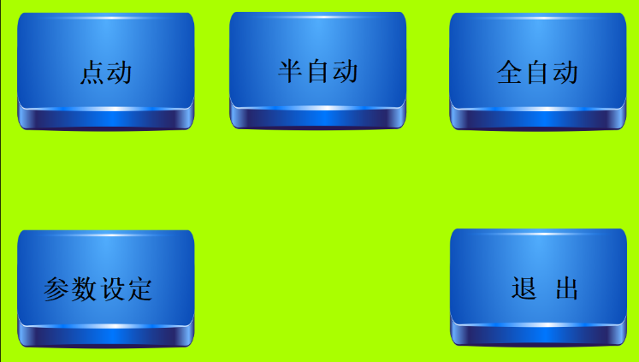

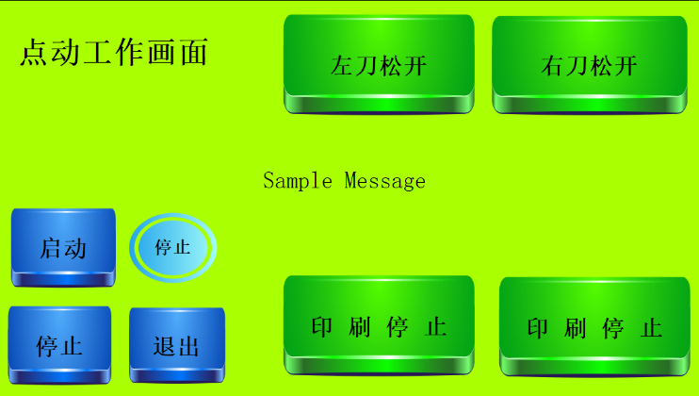
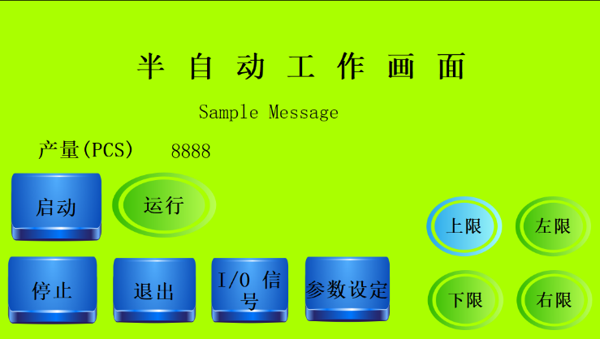
设备启动页面 功能选择页面

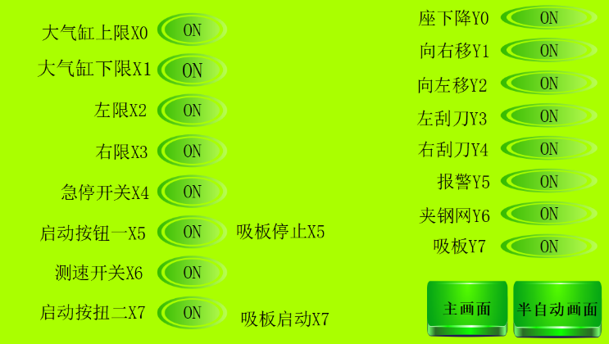
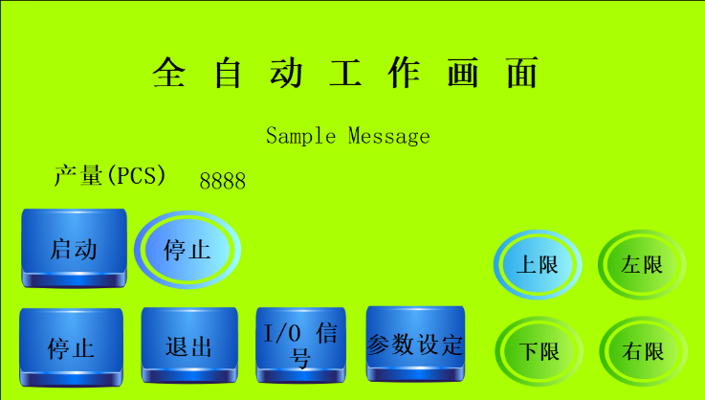
点动工作页面 半自动工作画面

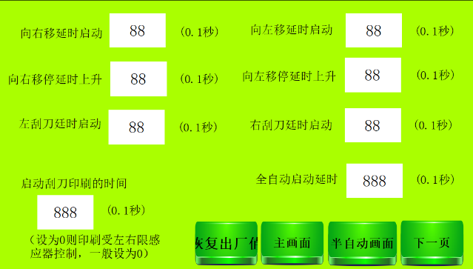
全自动工作画面（技术调试） I/O信号检测

参数设定页面
设备主体构造平面图
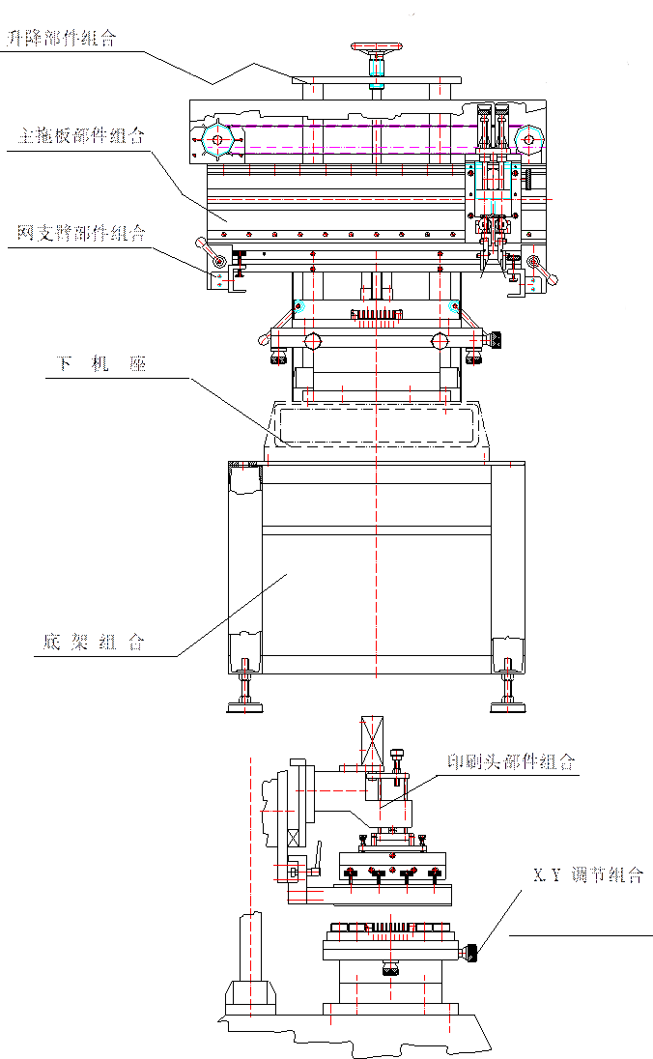

设备详细构造平面图

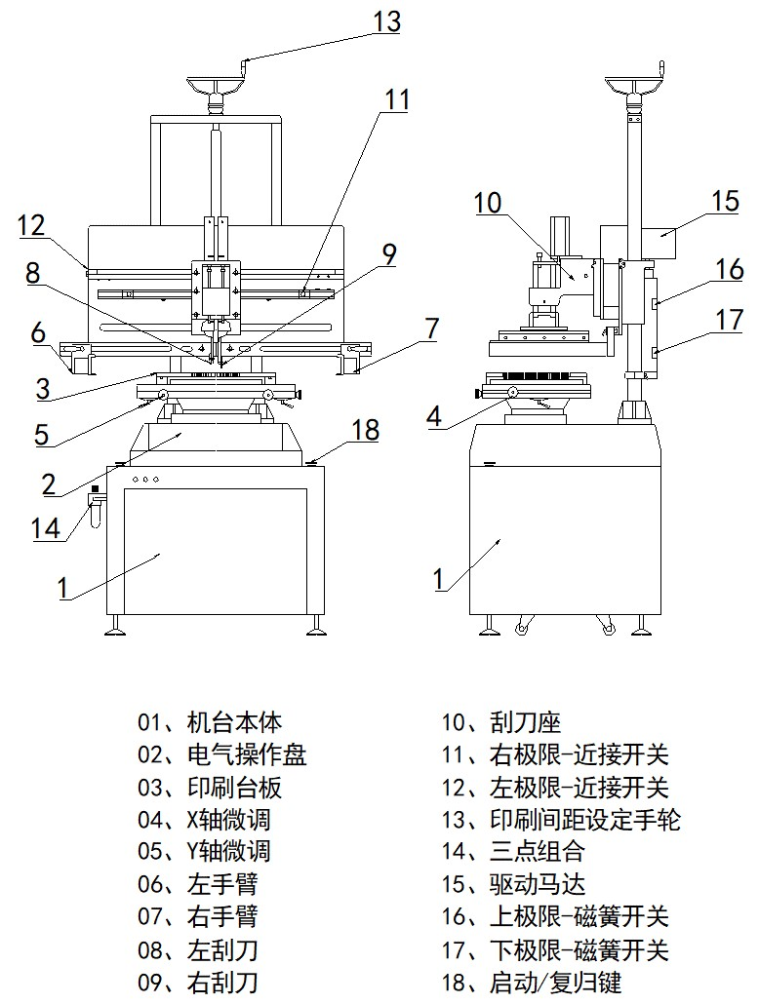

操控示意图
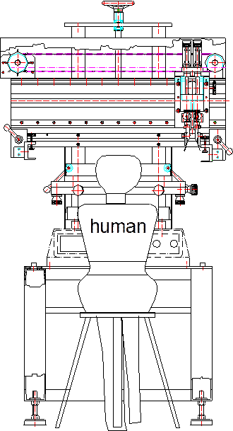

对钢网和印刷运行调整
Adjustment of steel mesh and printing operation
- 开启印刷机电源并开通压缩空气，将印刷头台起成45⁰并锁紧，将多孔板移回原位！
- 取一片准备生产的PCB根据PCB板厚度调节好4个定位针的高度，调整原则是定位针突出部分高度必须要略低于PCB厚度。否则装机运行后将会对刮刀和钢网造成损伤。
- 安装4个定位针将PCB定位于多孔板中央位置（焊盘面朝上）。如图：
- 如果PCB上找不到4个定位孔，则选择对角的两个定位孔。
- Turn on the power supply of the printer and turn on the compressed air, lift the printing head table into 450 and lock it, and move the perforated plate back to its original position!
- Take a piece of PCB to be produced and adjust the height of the four positioning pins according to the thickness of the PCB. The adjustment principle is that the height of the protruding part of the positioning pin must be slightly lower than the thickness of the PCB. Otherwise, the scraper and steel mesh will be damaged after installation and operation.
- Install 4 locating pins to position the PCB in the center of the perforated plate (pad face up). As shown in the figure:
- If 4 locating holes cannot be found on the PCB, select the two diagonally opposite locating holes.
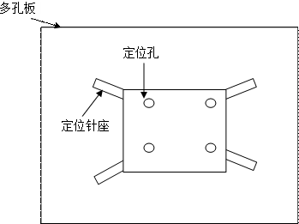
- 通过触摸屏手动方式将印刷机网臂降到最低，并将网臂调到最宽的位置。
- 将钢网放在已经定好位置的PCB上方，将网孔和焊盘大致对好。
- 将钢网锁紧螺丝全部松开，根据钢网位置（钢网应该大致与焊盘对好）移动两条网臂，将钢网装入网臂并锁紧
- 调整印刷间距调整手轮，使钢网底面与PCB刚好接触。观察PCB四个角是否同时刚好接触钢网，检查钢网平面与PCB平面是否平行。 通过调整X轴和Y轴3个螺杆移动印刷平台使PCB焊盘与钢网孔位置完全对准。
- 刮刀压力调整螺杆调至最低（压力最小的位置）
- 正确安装刮刀：要求刮刀架与刮刀夹具上平面必须紧贴；两刮刀安装必须对称、斜向朝外。如图
- Manually lower the screen arm of the printer to the lowest position through the touch screen, and adjust the screen arm to the widest position.
- Place the steel mesh above the PCB that has been positioned, and roughly align the mesh with the pad.
- Loosen all the locking screws of the steel mesh, move the two mesh arms according to the position of the steel mesh (the steel mesh should be roughly aligned with the pad), install the steel mesh into the mesh arm and lock it
- Adjust the printing spacing and adjust the hand wheel so that the bottom surface of the steel mesh is just in contact with the PCB. Observe whether the four corners of PCB just touch the steel mesh at the same time, and check whether the steel mesh plane is parallel to the PCB plane. Move the printing platform by adjusting the three screws of x-axis and y-axis to fully align the PCB pad with the steel mesh.
- Adjust the scraper pressure adjusting screw to the lowest position (the position with the lowest pressure)
- Correctly install the scraper: the scraper holder and the upper plane of the scraper fixture must be close; The two scrapers must be installed symmetrically and obliquely outward. As shown in the figure
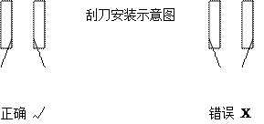
- 进入触摸屏点动画面，点左刮刀按钮并调整刮刀压力螺杆使刮刀接触钢网，观察刮刀底面是否与钢网平行。如果不平则调整刮刀平衡调整螺丝使其平行。（右刮刀同样方法调整）
- Enter the touch screen jog screen, click the left scraper button, adjust the scraper pressure screw to make the scraper contact the steel mesh, and observe whether the bottom surface of the scraper is parallel to the steel mesh. If not, adjust the scraper balance adjustment screw to make it parallel（ Right scraper (adjusted in the same way)
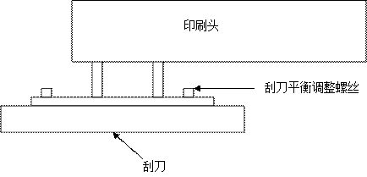
- 手动（或点动）将印刷头推靠左边，使右刮刀走过所有网孔约10mm左右。注意左刮刀不可碰到钢网框架或网臂。
- 调整左限位接近开关，使其刚好感应。（右限位同样操作）
- 通过触摸屏设置为点动状态，点左刮刀再点右移，在刮刀移动时仔细观察刮刀底面与钢网间的间隙，要求间隙无变化。
- 在钢网上添加约1/4瓶锡膏，进行手动试印刷（印刷前确保PCB已经处于正确安装并定位状态）
- 试印刷时为防止压力调整太大造成钢网和刮刀的损坏，试印刷前将刮刀压力调整为最小的状态然后按由小到大的调整原则。直到刮刀刚好将锡膏刮干净为止。
- 试印OK后即可进行半自动印刷测试。（操作方法见使用说明书）要求印刷后锡膏位置正确、无坍塌、拉尖、少锡、连锡现象。
- Manually (or inching) push the printing head to the left, so that the right scraper passes through all mesh holes by about 10mm. Note that the left scraper shall not touch the steel mesh frame or mesh arm.
- Adjust the left limit proximity switch so that it just senses（ Right limit (same operation)
- Set it to the inching state through the touch screen, click the left scraper and then move it to the right. When the scraper moves, carefully observe the gap between the scraper bottom and the steel mesh. It is required that the gap does not change.
- Add about 1 / 4 bottle of solder paste on the steel net for manual trial printing (ensure that the PCB is correctly installed and positioned before printing)
- During trial printing, in order to prevent damage to the steel mesh and scraper caused by too large pressure adjustment, adjust the scraper pressure to the minimum state before trial printing, and then adjust it from small to large. Until the scraper just scrapes the solder paste clean.
- After the trial printing is OK, the semi-automatic printing test can be carried out（ The operation method (see the operation manual) requires that the solder paste position after printing is correct without collapse, sharpening, less tin and tin connection.
试机和运转操作
Commissioning and operation
安装工程结束后，应对机器作一次认真而详细的开机检查，并进行试机，为正式投入生产做好准备，试机分空运转和试印刷两步进行工作。
After the completion of the installation project, the machine shall be carefully and carefully started up for inspection, and trial run shall be carried out to prepare for formal production. The trial run shall be divided into two steps: air operation and trial printing.
1、空运转
开机前，复查各主要螺栓、螺钉是否拧紧，收清机器上散放的工具各多余的零件，做好机器的清洁工作，各轴承、丝杆加足润滑油。点选触摸屏进入调试状态，点启动，机器开始自动运转。开机后进行检查，应达到下列主要要求：
  - 手摸机架无异常振动；
  - 目视印刷座升降平稳，无停顿等运行不良；
  - 目视同步带轮传动平稳；
  - 目视印刷头左右印刷运行平稳，无停顿等运行不良；
  - 目测控制面板触摸屏正常显示；
  - 目测刮刀上升下降平稳，无停顿等现象；
2、试印刷
试印刷在证明空运转正常的基础上进行，根据第三章“对板和印刷运行的调整”操作，在PCB板面（钢网板印刷范围下方）平放一张A4白纸，锡膏搅拌均匀后，将锡膏放于钢网上，在点动状态下试印刷，检查印刷后A4白纸上锡膏是否均匀，否则调整刮刀与钢网及钢网与PCB之间压力。印刷白纸合格后开始试印刷PCB，试印刷PCB主要检查以下几点：
  - 检查焊盘上锡膏的形状是否良好；
  - 检查印刷后焊盘锡膏与钢网上孔位是否吻合；
1. Air transfer
Before starting the machine, recheck whether the main bolts and screws are tightened, collect the spare parts of tools scattered on the machine, clean the machine, and add enough lubricating oil to all bearings and screw rods. Click the touch screen to enter the debugging state, click start, and the machine starts to run automatically. Check after startup, and the following main requirements shall be met:
a) Touch the frame by hand without abnormal vibration;
b) Visual inspection shows that the printing base rises and falls stably without pause and other poor operation;
c) Visually check that the synchronous pulley drives smoothly;
d) Visually inspect the left and right printing of the printing head, and the printing operation is stable without pause and other poor operation;
e) Visually check that the touch screen of the control panel displays normally;
f) Visually check that the scraper rises and falls steadily without pause;
2. Trial printing
The trial printing is carried out on the basis of proving that the idling operation is normal. According to the operation of Chapter III "adjustment of board and printing operation", lay a piece of A4 white paper flat on the PCB board surface (below the printing range of steel screen). After the solder paste is stirred evenly, put the solder paste on the steel screen, test print in the inching state, and check whether the solder paste on the A4 white paper is uniform after printing, Otherwise, adjust the pressure between the scraper and the steel mesh and between the steel mesh and PCB. After the printed white paper is qualified, the trial printing of PCB shall be started. The trial printing of PCB mainly checks the following points:
  - Check whether the shape of solder paste on the pad is good;
  - Check whether the solder paste on the pad after printing is consistent with the hole position on the steel mesh;
设备操作步骤
Equipment operation steps
一、整机操作
1.1调试完毕后，接通单相220V电源和气源；
1.2通过定位PIN和顶针将PCB固定，安装钢网，对板调整，调整印刷速度；
1.3启动电源控制开关，解除紧急停止按钮的自锁；
1.4点击触摸屏“半自动”，双手分别同时按住机座上左右启动开关；
1.5机器开始左右印刷，印刷完毕后，取出PCB；
1.6重新放置PCB并固定，重复上述动作；
1.7关闭电源控制开关和紧急停止按钮；
1.8 清洁机器表面，抬起刮刀头。
Ⅰ、 Whole machine operation
1.1 after commissioning, connect single-phase 220V power supply and air source;
1.2 fix the PCB by positioning pin and thimble, install steel mesh, adjust the board and adjust the printing speed;
1.3 start the power control switch and release the self-locking of the emergency stop button;
1.4 click "semi-automatic" on the touch screen, and press and hold the left and right start switches on the base with both hands at the same time;
1.5 the machine starts to print left and right. After printing, take out the PCB;
1.6 reposition and fix the PCB, and repeat the above actions;
1.7 turn off the power control switch and emergency stop button;
1.8 clean the machine surface and lift the scraper head.
二、电气系统操作
1、概述
该机电气系统采用单相220V电源供电，该系统主要由PLC、变频器及触摸屏等组成。该机的电气操作控制部件及显示器集中安装在操作面板上（见第三章“机器的操作面板”）。该机的电气原理图及接线图见附图。
2、操作步骤（说明）
2.1按下电源控制开关，解除紧急停止按钮的自锁，此时触摸屏在5秒钟后显示开机屏幕；
2.2点“进入系统”，进入主菜单画面；
2.3触摸点击“全自动”，可进入调试界面，此菜单显示；
触摸“启动”机器会按设定间歇时间自动运行。测试结束触摸“停止”会停止自动运行并返回模式选择菜单。
*该状态仅用于测试机器自动运行时的状态，及机器老化测试！不可用于生产工作。
2.4触摸 “点动”进入点动菜单画面，

在该状态下可单独测试某个动作的动作情况：触摸“左刀”左刀下，再次触摸左刀返回。右刀动作同样
触摸“左印刷”刮刀头向左移动，或点“右印刷”刮刀头向右移动。此时调整速度旋钮以调整刮刀移动速度，速度值会显示在画面中央。（注：由于计算速度需要时间，所以显示速度有所延迟是正常的）。
在点动画面下，同时按机器左右两个启动按钮，钢网会下降，可测试主气缸控制升降情况。
触摸“返回”返回“模式选择”菜单；
2.5进入半自动画面；
画面中“上、下、左、右表示机器的四个感应器，背景红色表示没有感应信号，背景绿色表示有感应信号！“计数”自动记录印刷PCB板数量，“复位”清除“计数”数值。
“上、下“表示主气缸的上下两个雌簧开关，“左、右”表示刮刀行程控制接近开关。
在此画面，同时按机器左右两个启动按钮时，机器进入正常工作状态。（必须同时具备两个感应器有信号时半自动才能工作！）
触摸“返回”返回“功能选择”菜单
2.6 触摸“印刷设定”进入参数设定画面：
2.6.1 触摸“计数控制” 同时设定好计划产量可以开启生产计数功能，否则该功能处于关闭状态。触摸“警报控制”开启每到达设定生产数量后报警提醒清洗钢网的动能。
触摸“一次印刷”可以切换成“二次印刷”意思是每片板印一次或者两次。
触摸“左刮启动”和“右刮启动”可设定，左刮刀或右刮刀下刀延时时间。该功能仅用于需要刮刀先移动后下刀功能时才采用，一般设定为“0”
下面参数设置用于设置自动或半自动模式下各动作间的停顿时间。
“左上停”时间表示刮刀回到原位且刀头在左边限位处时停顿的时间；
“左下停”表示机头在左限位处刮刀动作与向右印刷动作间的间歇时间；
“全动停” 将所有调试状态时各动作间的间歇时间。
“右上停”表示刮刀回到原位且刀头在右边限位处时停顿的时间；
“右下停”表示机头在右限位处刮刀动作与向左印刷动作间的间歇时间；
可以触摸##处修改各数值，单位是MS。
2.7 点击“监控模式”可以进入设备信号输入点监控画面。在该画面里您可方便的了解各信号输入情况，方便检修。
Ⅱ、 Electrical system operation
1. Overview
The electrical system of the machine adopts single-phase 220V power supply. The system is mainly composed of PLC, frequency converter and touch screen. The electrical operation control components and display of the machine are centrally installed on the operation panel (see Chapter III "operation panel of the machine"). See the attached figure for the electrical schematic diagram and wiring diagram of the machine.
2. Operating steps (description)
2.1 press the power control switch to release the self-locking of the emergency stop button. At this time, the touch screen displays the startup screen after 5 seconds;
2.2 click "enter system" to enter the main menu screen;
2.3 touch and click "full automatic" to enter the commissioning interface, and this menu is displayed;
Touch "start" and the machine will run automatically according to the set interval time. At the end of the test, touching "stop" will stop the automatic operation and return to the mode selection menu.
*This state is only used to test the state of the machine during automatic operation and machine aging test! Not available for production work.
2.4 touch "jog" to enter the jog menu screen,
In this state, the action of an action can be tested separately: touch "left knife" under the left knife, and touch the left knife again to return. The right knife moves the same
Touch "left printing" to move the scraper head to the left, or click "right printing" to move the scraper head to the right. At this time, adjust the speed knob to adjust the moving speed of the scraper, and the speed value will be displayed in the center of the screen（ Note: since it takes time to calculate the speed, it is normal to delay the display speed).
In the jog screen, press the left and right start buttons of the machine at the same time, the steel mesh will fall, and the lifting control of the main cylinder can be tested.
Touch "return" to return to the "mode selection" menu;
2.5 enter the semi-automatic screen;
In the picture, "up, down, left and right" indicates the four sensors of the machine. The background red indicates that there is no sensing signal, and the background green indicates that there is sensing signal“ Count automatically records the number of printed PCB boards, and reset clears the count value.
"Up" and "down" represent the upper and lower female spring switches of the main cylinder, "left" and "right" represent the scraper stroke control proximity switch.
On this screen, press the left and right start buttons of the machine at the same time, and the machine will enter the normal working state（ It must have two sensors at the same time, and the semi-automatic can work only when there is a signal!)
Touch "back" to return to the "function selection" menu
2.6 touch "print setting" to enter the parameter setting screen:
2.6.1 touch "counting control" and set the planned output at the same time to turn on the production counting function, otherwise the function is turned off. Touch "alarm control" to start the alarm to remind the kinetic energy of steel mesh cleaning after reaching the set production quantity.
Touch "primary printing" to switch to "secondary printing", which means that each plate is printed once or twice.
Touch "start of left scraping" and "start of right scraping" to set the delay time of cutting of left scraper or right scraper. This function is only used when the scraper needs to move first and then lower the blade. It is generally set to "0"
The following parameter settings are used to set the pause time between actions in automatic or semi-automatic mode.
"Top left stop" time means the time when the scraper returns to the original position and the cutter head stops at the left limit;
"Lower left stop" indicates the interval between the scraper action and the right printing action of the head at the left limit;
"Full stop" refers to the interval time between actions in all commissioning states.
"Top right stop" means the time when the scraper returns to the original position and the cutter head stops at the right limit
"Lower right stop" indicates the interval between the scraper action and the left printing action of the head at the right limit;
Each value can be modified by touching ## the unit is Ms.
2.7 click "monitoring mode" to enter the monitoring screen of equipment signal input point. In this screen, you can easily understand the signal input for maintenance.
操作注意事项
在机器运行时禁止修改触摸屏参数；
生产运行中禁止手放在钢网与工作台间及网支臂下；
生产发现异常时，请及时按急停开关，并关闭电源控制开关；
生产运行前必须检查左右限位感应器和气缸上下磁性感应器灵敏度；
生产运行前请检查印刷头位置必须处于原点,左右限位感应器,处于适当的位置,不可超出左右网臂(防止撞刀)
Precautions for operation
It is forbidden to modify touch screen parameters when the machine is running;
It is forbidden to put your hands between the steel mesh and the workbench and under the mesh support arm during production and operation;
In case of any abnormality in production, please press the emergency stop switch in time and turn off the power control switch;
Before production and operation, the sensitivity of left and right limit sensors and upper and lower magnetic sensors of cylinder must be checked;
Before production and operation, please check that the position of the printing head must be at the origin, the left and right limit sensors must be at the appropriate position, and shall not exceed the left and right mesh arms (to prevent knife collision)

操作工艺设定流程

合上电源、接通气源

报警/印刷次数是否设定
机器是否正常启动
正常运行
断开电源
触摸屏初始化
延时设定是否完成
是
是
是
否
设定各参数值返回
是
否
设定各参数值返回
查看急停按钮是否按下
否

各工艺数据是否满足印刷要求
修改各工艺数据

返回半自动画面
是
复位按钮是否按下
是
停止按钮是否按下

常见故障处理措施

故障现象 | 故障原因 | 解决方法
电源无法开启 | 未正常接入220V电源 | 检查外部供电电源
 | 电源按钮坏 | 更换电源按钮
 | 保险管坏 | 检查无问题后  更换新保险管
 | 电源继电器坏 | 更换新继电器
网板无法上升、下降 | 气压未输入或气压不足； | 正常气压应保持在4-6kg/cm²
 | 上升顶点感应器未感应或已损坏、断线、上下电磁阀故障、PLC故障 | 调节顶点感应器或更换感应器、更换电磁阀或PLC
 | 印刷功能未选择 | 正确选择印刷功能
 | 上下气缸调速阀不良或调整不当 | 换气缸调速阀或重新调整
刮刀无法左右印刷 | 速度调节太小 | 调整速度旋钮
 | 接近开关未感应印刷座 | 印刷座移动到接近开关原点
 | 变频器或电位器故障 | 更换变频器或电位器
 | 4A保险管坏 | 更换4A保险管
 | 信号连接断 | 更换信号连接线
刮刀左右印刷无法停止和上升 | 接近开关损坏 | 更换接近开关
网板下降未印刷即上升 | 左右近接感应器损坏或短路 | 重新更换近接感应器
 | 电磁阀损坏 | 更换电磁阀
 | 近接感应器被变频器干扰 | 在感应器负电源与OUPUT并联一个0.1uf电容器
变频器无法启动或无法驱动马达  刮刀无法上升或下降 | 变频器参数设定有错误 | 重新设定变频器参数
 | 变频器损坏 | 更换变频器
 | 保险管坏 | 更换新保险管
 | 刮刀小气缸电磁阀故障 | 更换电磁阀
 | 刮刀气缸微调不良或调整不当 | 重新调整或更换微调
变频器无显示 | 电源未正常开启 | 开启机器电源
定期保全
定期保全是除日常的检修事项外，按规定的周期，将机械停止下来，有计划地进行平时难于确认的问题检查修整，为了安全运转，提高品质，有部分损坏是不能够运转工作的。通常每月进行重点检修一次，每年一次进行检验各部分旋转情况、运动部件的磨损情况、振动等情况。
一、刮刀
每天工作完后检查刮刀不得有变形、污垢，应及时去除污垢；
每天检查刮刀上升下降不得有停顿现象；
二、印刷头
每天检查印刷头左右横移在限点位置必须能停止；
每天检查印刷头在左右印刷过程不得有阻碍停顿现象；
每月检查印刷座Y向移动灵活，锁紧螺丝不得松动；
三、传动升降
传动机构如长期印刷，对机械有较大的冲击，要经常检查传动部位的螺丝、紧固螺钉等有无松动，同步带与带轮的啮合是否正常，传动机械有无异常、发热；
印刷升降立柱因长期升降工作，请确认立柱座轴承是否损坏，立柱是否有油类和污垢粘附着，请及时清除污垢，涂敷润滑油立柱、升降丝杆、气缸导杆请每周加润滑油；
线性导轨、滑块请每周加油。

运输及吊装
1、吊装
2、铲车装卸或搬运
注：采用吊装或铲车装卸或搬运时，必须注意机器的重心！

附：设备电气原理图

