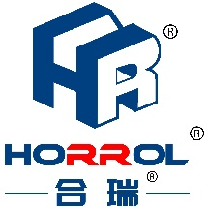
全自动鞋底清洗机
Full automatic sole cleaning machine
专利号：ZL 2019 2 1727573.9

鞋底清洁机作为一种入口鞋底清洁设备，旨在解决由鞋底带进室内的污尘问题。通过鞋底清洗机自动感应启动，浸湿的履带毛刷旋转摩擦鞋底，从而清理掉鞋底污尘，将污尘阻挡在入口处，减少室内地面清洁工作量，鞋底洗鞋机为保持室内环境洁净度树立一道屏障。
As an imported sole cleaning equipment, sole cleaner aims to solve the problem of dirt brought into the room by the sole. Through the automatic induction start of the sole cleaning machine, the wet crawler brush rotates and rubs the sole, so as to remove the dirt on the sole, block the dirt at the entrance, and reduce the workload of indoor ground cleaning. The sole washing machine establishes a barrier to maintain the cleanliness of the indoor environment。
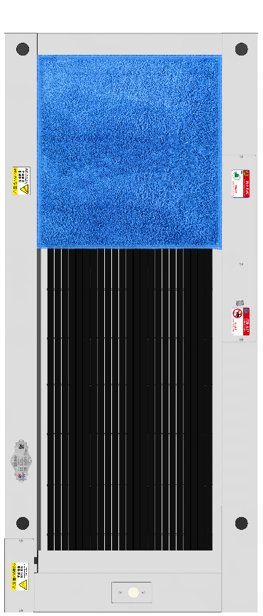

HRSC-1800技术参数
规格型号 | HRSC-1800 | 工作模式 | 手自一体，一键切换
外形尺寸 | 1800x760x135mm | 高低水位 | 高低自动检测控制
洗刷尺寸 | 970x550 | 承载重量 | 500kg
吸干尺寸 | 575x550mm | 钣金材质 | 1.5mm厚304不锈钢
电压负荷 | 220v,50Hz/200w | 传动及轴承材质 | 304不锈钢
水泵电压功率 | DC24V/90w | 吸水垫材质 | 复合珊瑚绒
排污泵扬程 | 15米 | 自动换水控制 | 人数时间计算
启动方式 | 雷达微波感应 | 皮带毛刷材质 | 进口尼龙及聚氨酯
运行速度 | 110r/min | 皮带毛刷数量 | 23条
安全防护 | 漏电保护 | 扶手配置 | 选配（另外添加）

企业名称：广东合瑞科技有限公司
企业地址：广东省东莞市寮步镇石龙坑龙泉路197号
企业官网：www.horrol.com

